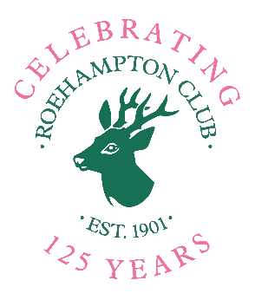
Filming and Photography at Roehampton Club
Consent form for use at the Club’s
125 Year Celebrations Exhibition only
 | Delete as required:
I give permission for my / my child’s photograph to be taken at Roehampton Club and exhibited in printed or electronic form at Roehampton Club during and for the sole purpose of the Club’s 125-Year Celebrations in 2026. | YES / NO
I give permission for my / my child’s photograph to be taken at Roehampton Club and reproduced as an artwork, using a range of media including, but not limited to, paint, pastel and pencil, and for that artwork, or a photograph of it in electronic form, to be exhibited at Roehampton Club for the sole purpose of the Club’s 125 Year Celebrations. | YES / NO
I give permission for videos of myself / my child to be taken at Roehampton Club and shown / exhibited at the Club for the purpose of the Club’s 125 Year Celebrations | YES / NO

Please complete this form as it relates to you, return a hard copy to Helen Bolt, Marketing and Membership Manager or via email to helen.bolt@roehamptonclub.co.uk and send an electronic copy to 125artwork@roehamptonclub.co.uk as requested in the exhibition instructions

I (name):

Child’s name:

Hereby give permission for my / my child’s photograph to be taken and used as above:
Signature:

Date:

Photographer / Artist / Videographer name:

Signature:

Date:

