Roehampton Club Art Group  Art Exhibition and Sale 2022  Entry Form | 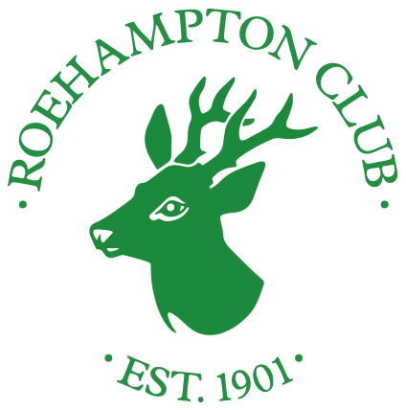

How to enter
Complete and sign this form and hand it to reception with £5 for each artwork entered by 5pm, Friday 14th October. Items for the hopper are free.

By signing this form:
I confirm I am a member of the Art Group and wish to enter the items listed below into the Art Group Exhibition and Sale 2022.
I will deliver the items listed below to the Fountain Room between 5 and 7pm on Sunday the 6th November and collect them from the bridge room between 9 and 11am on Saturday the 19th November.
I accept: 1. The terms and conditions set out in this form and the Entry Instruction form dated September 2022; 2. That all decisions are the sole discretion of the Art Group; 3. That neither the Club or the Art Group are responsible for any loss or damage to exhibits, for any part of a sale process or for the storage of any item.

Print name Signature

Phone number Email

TITLE MEDIUM PRICE

1.…………………………………………………………………………………..……………………………………..……………………..
2.…………………………………………………………………………………..……………………………………..……………………..
3.…………………………………………………………………………………..……………………………………..……………………..
4………………………………………………………………………………………………………………………………………………….
5………………………………………………………………………………………………………………………………………………….
Number of items for the browser: ………………..
Payment taken by: | Amount paid: £ | Date:
September 2022

