Art Group / PhotoClub membership form 2021  Roehampton Club Art Group and PhotoClub are thriving sections within the  Club and include all our art and photography activities. Regular Art Group lectures take place on the third Tuesday of the month at 7pm via zoom. Please see the noticeboard in Reception, the Roehampton Recorder fortnightly e-newsletter for up-coming events, lectures and classes. |  | 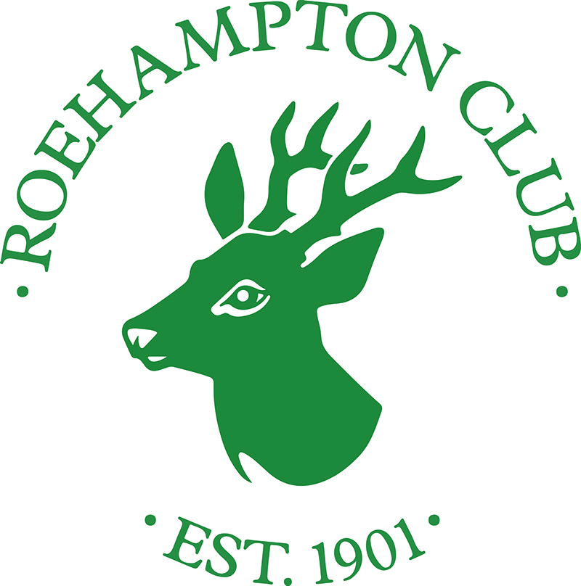
Annual subscription
The £20 annual subscription payable on joining and annually thereafter, provides free access to six annual lectures by art experts, membership of the Art Group and PhotoClub, special rates for events plus the opportunity to join our successful photography, drawing and painting courses.

Please pay the first £20 joining fee / Art Group subscription by cash, card or cheque payable to Roehampton Club Ltd. £20 will be added to your membership record to be taken with your annual Club subscription direct debit at the start of the second year and subsequent years.
If you decide not to continue your Art Group membership, please let us know and we will remove the annual payment from your account.
Name
Roehampton Club membership number
Telephone
Email

Subject interest – please tick one or more
Art classes |  | Photography
Art lectures |  | Photography classes
Art / photo visits |  | Photography lectures

Signed
Date
Please hand this completed form to Reception for the attention of Helen Bolt, Marketing and Membership Manager. Or post to Helen Bolt, Roehampton Club, Roehampton Lane SW15 5LR
By completing this form you agree to share your contact information with Art Group Committee Members and to receive occasional information about up-coming events and courses.
If you would rather not share your contact information or receive Art Group information via email, please tick here

Art Group and PhotoClub
Membership Form

FAO Helen Bolt
Roehampton Club

