WW2 and celebrating VE Day | 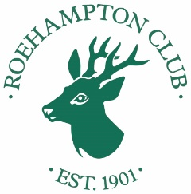

1. Who commanded the Eighth Army at El Alamein?

2. Which island was awarded the George Cross for gallantry?

3. In which French area were the D-Day landings?

4. In which year did the German Army invade Russia?

5. In which two Japanese cities were the first 2 atomic bombs dropped?

6. Name either of the two British ships sunk off Malaya three days after Japan entered the war?

7. Which officer led the Dambusters?

8. Adolf Hitler predicted the war in his memoir published in 1925. What was it called?

9. What name was given to the dead man, deliberately dropped into the sea to be found by German agents, who carried false papers to deceive the Axis powers about Allied intentions to attack Europe?

10. Which football club’s ground was used as a prisoner of war camp until May 1945 during the second World War?

11. What was the name of the French underground movement that fought against the Germans in World War II?

12. The nations involved in the war formed two opposing alliances. What were they called?

